**   **

Mobile Application Development

Project Document



Project Name: Express Application

School: Big Data & Software School

Adviser: Dr.Feno

Student Name: Yuteng Long

Student ID: 20161655

March 24th, 2019

Index

1 Introduction 3

1.1 Purpose 3

1.2 Description 3

1.3 Function 3

1.4 Constraints 3

2 System Overview 4

2.1 System Structure 4

2.2 Functional Requirements 4

2.3 Non-Functional Requirement 6

3 Architectural Design 6

3.1 Architectural Description 6

4 Database Description 11

4.1 Description of Each Table 12

4.2 Entity Relation 12

5 Install & Configure 13

# Introduction

## Purpose

In today's society, with the popularity of online shopping, the express delivery industry has gradually developed. In China, college students account for the majority of online shoppers, and various express stations have been set up in universities to make it easy for students to sign for express delivery. However, the courier can only store about 2~3 days in the station. If a student is busy with other things during that time, he will miss his courier. Therefore, the purpose of my express mobile application is to allow busy students to seek help from other students and help them sign for express delivery.

## Description

The mobile application audience is students of Chongqing University. By registering and logging in the account, you can check the progress of the courier according to the courier number and generate an order containing your own courier information. Others can receive the order and chat in the order to help the employer sign the receipt. The courier is then handed over to the employer. Students can also perform account management operations such as entering the address in advance and modifying the account password.

## Function

The Express Application is being developed for the college. The important modules that are going to implement in the proposed system.

1. Registration and login
2. Check express
3. Generate new orders
4. Accept order
5. Chat
6. Account management

## Constraints

Operating system limits: Android

# System Overview

The Express Application is a web-based application which is able to check express about the progress, and generate new orders, which others can accept and help you to sign the express.

Basically, there are three views for the convenience of the user. In the Home view the user can check the express by entering express company and number, in the Account view the user can manage their account and in Order view the user can generate new order, check the order etc., these are the main functions of the system.

## System Structure

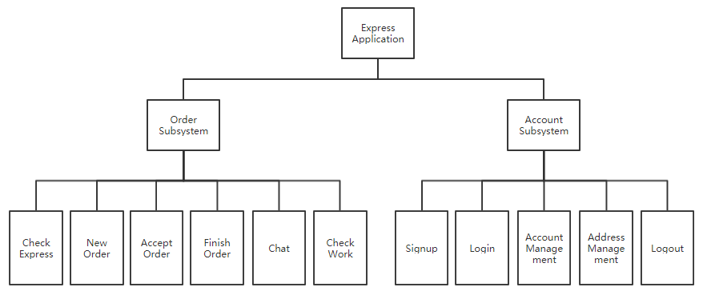

Figure 1. System Structure Diagram

This application can be divided into two subsystems: the order subsystem and the account subsystem. Under the order subsystem, users can query express, create new orders, accept orders, complete orders and communicate on the order page. When you are an employee, you can view the orders that have already been accepted. In the account subsystem, after registering an account, the user becomes a user, and the user can log in, log out, manage the address and account information.

## Functional Requirements

Dataflow diagram is the graphical system model that shows all main requirements for an IS in one diagram.

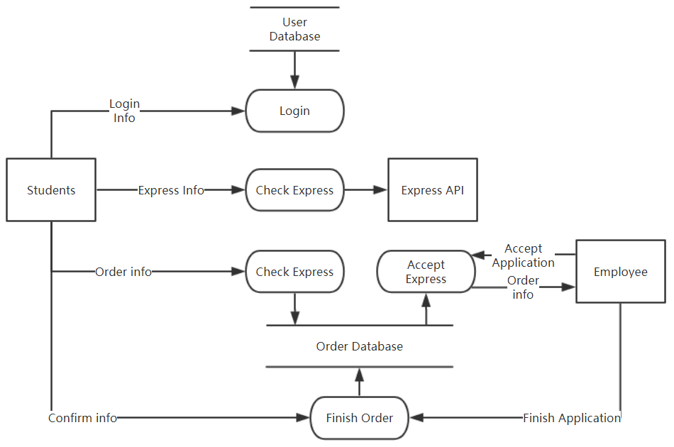

Figure 2. Dataflow Diagram

The data dictionary is then used to define all the data elements used in the system, for people to query the interpretation of the items that are not understood.

Name: Login Info

Description: Used to Login

Definition: Login Info = Student ID + Password

Location: Output to Login

Name: Express Info

Description: Necessary Info for checking express

Definition: Express Info = Express Company + Express Number

Location: Output to Check Express

Name: Order Info

Description: Necessary info for the order

Definition: Order Info = student name + phone number + Express Info + fee + deadline + address

Location: From Students output to New Order

Name: Accept Application

Description: Application from employee to accept the order

Definition:

Location: From employee output to Accept Order

Name: Finish Application

Description: When employee finish the order, he can applicate that the order is finished

Definition:

Location: From Employee output to Finish Order

Name: Confirm Info

Description: Student Confirm the order had been finished

Definition:

Location: From Student output to Finish Order

## Non-Functional Requirement

User Interface:

Android Studio 3.3.1 integrated development tools, bomb cloud database and Aliyun express query interface.

Software Interface:

Message transfer is performed between each module process by means of function calls, parameter passing, and return values. Interface passing information is data encapsulated in a data structure, passed between modules in the form of parameter passing or return values.

Security:

The software has good security, password verification, hidden privacy, and backup function.

# Architectural Design

## Architectural Description

Name: Login Page

Description: The login page contains a text field for the user ID and password, as well as buttons for logging in and buttons for jumping to the registration page.

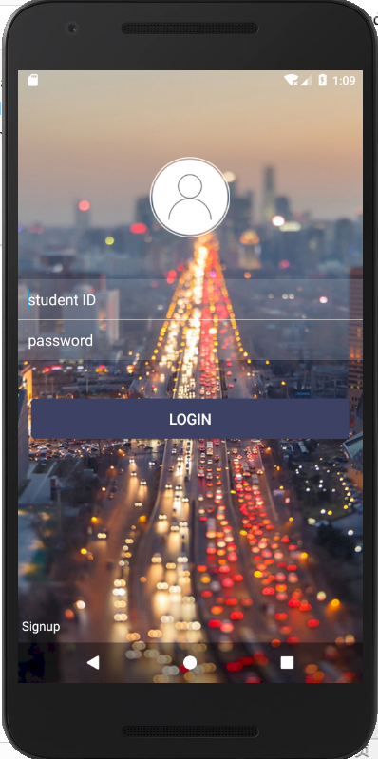 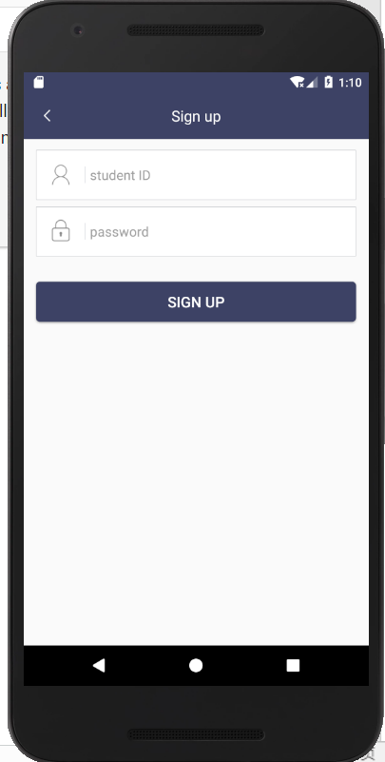

Figure 3. Login Page and Signup Page

Name: Sign Page

Description: The Signup Page contains a text field for the user ID and password, as well as a button to register and a button to return to the login page. After successful registration, the user information is written to the cloud database.

Name: Home Page

Description: The Home Page includes the selection of the courier company and the completion of the courier number. The upper limit of the text number of the courier number is 16 digits. After entering the correct courier number and the courier company, you can check the progress of the courier. The button below toggles the page.

Express number error - prompt express number error

Operations:

Pre-condition: Login success

Post-condition: presents search result

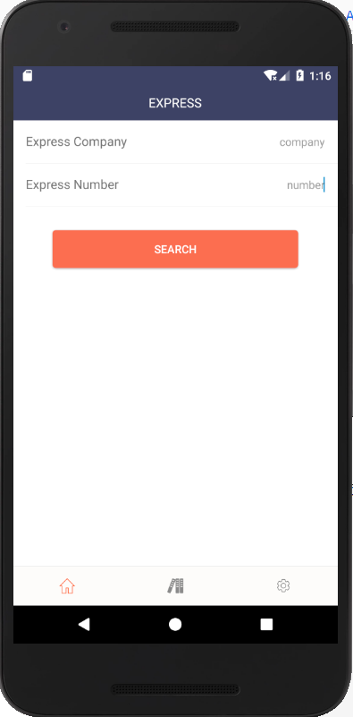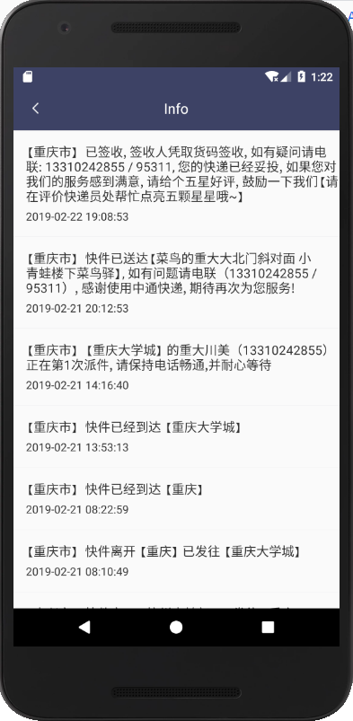

Figure 4. Home Page and Search Result

Name: Order Page

Description: The Orders page contains two sub-pages, My Orders and Acceptable Orders. View my generated orders in My Orders and view the orders of others who can be picked up on the Acceptable Orders page. The button in the upper right corner can generate new orders, and each order can be clicked to view detailed information.

Operations:

Pre-condition: Login success

Post-condition: presents order details, fill in the new order information

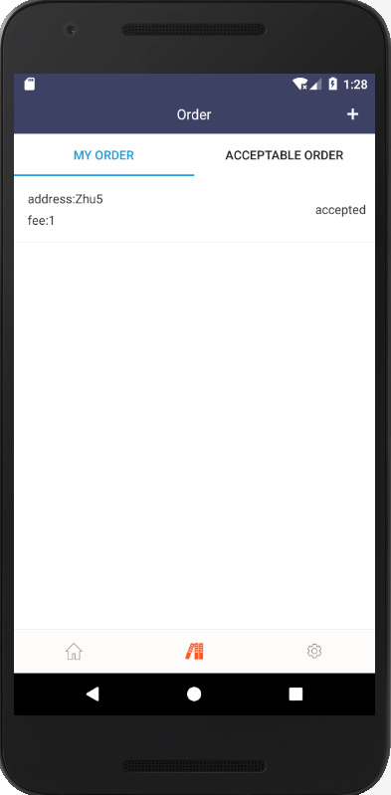 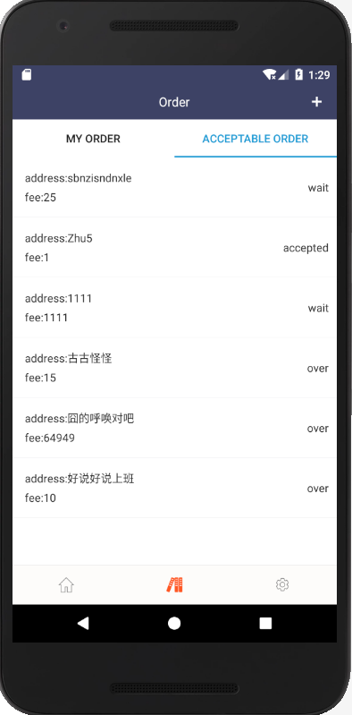

Figure 5. Order Page

Name: Order Info Page

Description: This page contains the details of each order but hides the privacy of the employer, showing only the delivery order number, address, cost and deadline. Orders that are not accepted can be accepted and can be contacted with the employer below after acceptance.

Operations:

Pre-condition: Click Order

Post-condition: accept order, send message

Name: New Order Page

Description: This page is used to generate new orders, names, phone numbers and addresses can be saved in advance. The order is generated after clicking the button and the order is in an acceptable state.

Operations:

Pre-condition: Click New Order Button

Post-condition: generate new order

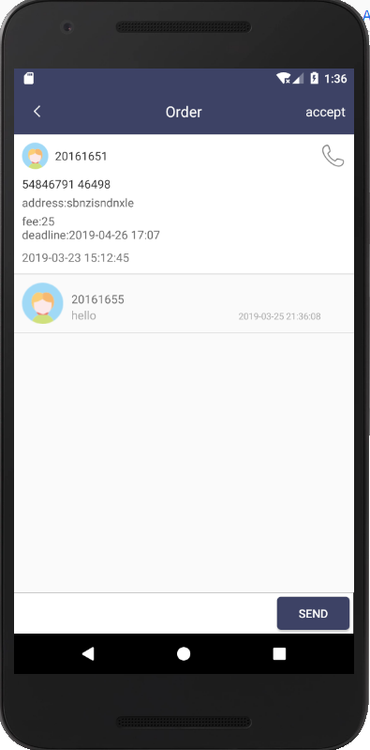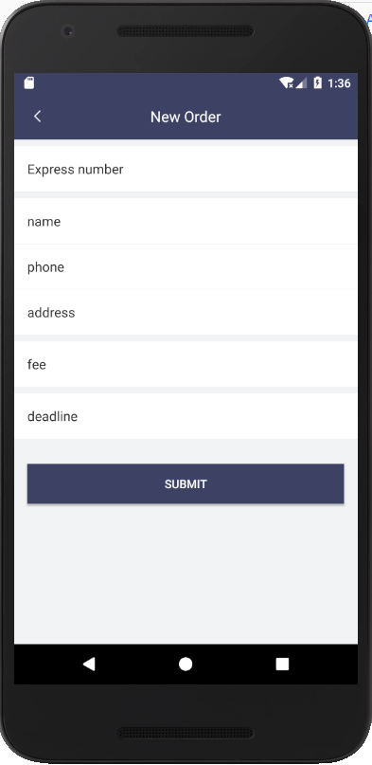

Figure 6. Order Info Page and New Order Page

Name: Account Page

Description: The Account Page is used to view information related to the account, display the user ID of the user, enter the address, modify the phone and email, view the orders accepted by you, and customer service consultation and logout.

Operations:

Pre-condition: Login success

Post-condition: Click button

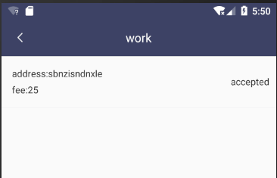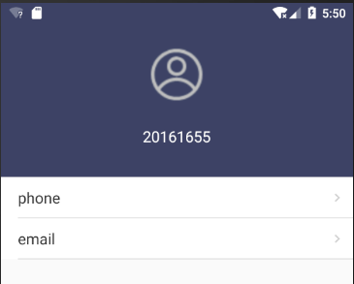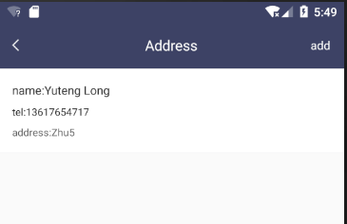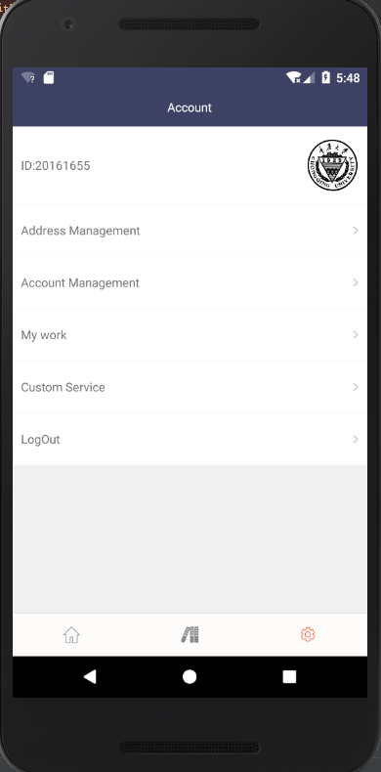

Figure 7. Account Page

# Database Description

The Database for Express application consists of 4 tables. They are:

User

OrderBean

Comment

Address

## Description of Each Table

User:

The user table stores all the basic information of the user, including the user ID, password, mailbox, phone attributes, and the user ID attribute is the primary key.

OrderBean:

The OrderBean table stores information about all orders, including the user ID, address, name, reward, phone, time, courier number, and status attributes.

Comment:

The Comment table is used to store chat information, including user ID, content, and the order attribute to which it belongs.

Address:

The Address table is used to store address information, including user ID, address, name, and phone attributes.

## Entity Relation

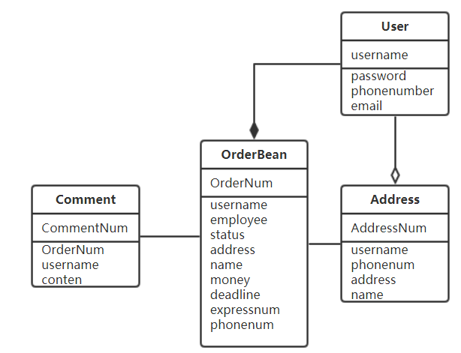

Figure 8. Entity Relation Diagram

# Install & Configure

If you want to use the Express application on your Android phone, please confirm the "USB installation" and "USB debugging" option in the Android phone settings, then connect the phone to the computer, make sure the computer has Android drivers installed, use Android Studio Install the application on your Android phone.

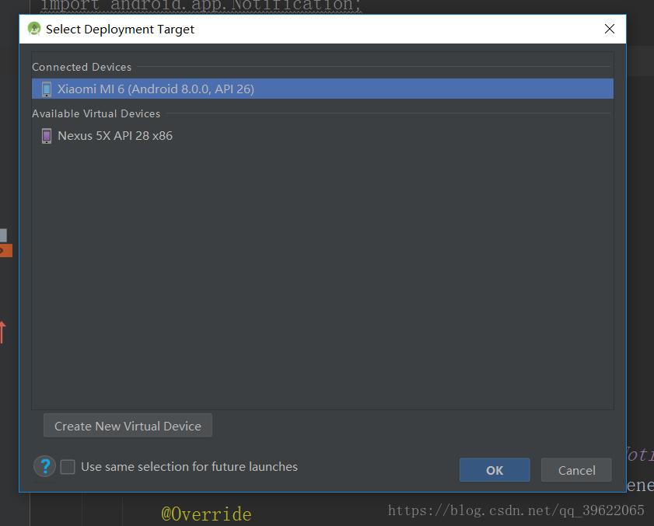

After clicking Run, Android Studio will configure it, and the app will run normally on your Android phone. Since the app requires an internet environment, make sure your phone is connected to the network.